Example: Advertisement responses (ad_responses.R)

Suppose you want to determine the effect that advertisement size (inches²) and newspaper circulation has on the number of advertisement responses. Suppose the data below is advertisements placed in newspapers of 6 different communities.

Ad. Responses | Size | Circulation
100 | 1 | 20,000
400 | 8 | 80,000
100 | 3 | 10,000
300 | 5 | 70,000
200 | 6 | 40,000
400 | 10 | 60,000

The R program shown next demonstrates how to do the following:

- Use matrix methods to find b and other important items.
Note that 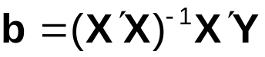
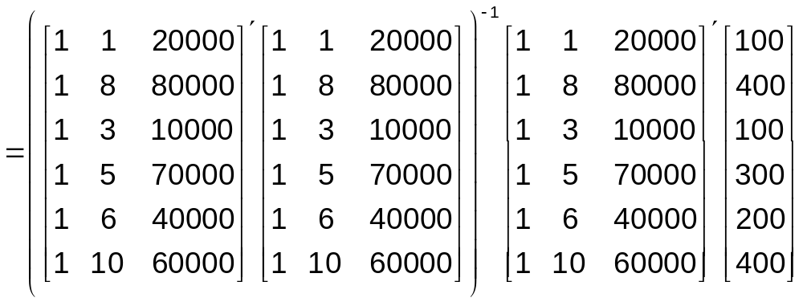
- Use lm() to find b and other important items. Note that we will use lm() almost exclusively for multiple linear regression (instead of direct matrix methods).
- Create a scatter plot of the data and of the sample regression model’s plane.
- Examine the relationship between ad. responses and a predictor variable holding the other predictor variable constant.

Get data into R:

> ad.responses<-c(100, 400, 100, 300, 200, 400)
> size<-c(1, 8, 3, 5, 6, 10)
> circulation<-c(20000, 80000, 10000, 70000, 40000, 60000)

> set1<-data.frame(ad.responses, size, circulation)
> set1
ad.responses size circulation
1 100 1 20000
2 400 8 80000
3 100 3 10000
4 300 5 70000
5 200 6 40000
6 400 10 60000

- Use matrix methods to find b and other important items.

> X<-cbind(1, set1$size, set1$circulation)
> Y<-set1$ad.responses
> b<-solve(t(X)%*%X) %*% t(X)%*%Y
> b
[,1]
[1,] 6.397188049
[2,] 20.492091388
[3,] 0.002804921

> Y.hat<-X%*%b
> e<-Y-Y.hat
> n<-length(Y)
> J<-matrix(data = 1, nrow = n, ncol = n)
> SSTO<-t(Y)%*%Y-1/n*t(Y)%*%J%*%Y
> SSE<-t(e)%*%e
> MSE<-SSE/(n-nrow(b))
> SSR = SSTO - SSE
> data.frame(X, Y, Y.hat, e)
X1 X2 X3 Y Y.hat e
1 1 1 20000 100 82.98770 17.012302
2 1 8 80000 400 394.72759 5.272408
3 1 3 10000 100 95.92267 4.077329
4 1 5 70000 300 305.20211 -5.202109
5 1 6 40000 200 241.54657 -41.546573
6 1 10 60000 400 379.61336 20.386643

Notice that R uses a default X1, X2, X3 for the column names of X (X is a matrix class type without names)

> data.frame(n, SSTO, SSE, MSE, SSR)
n SSTO SSE MSE SSR
1 6 95000 2502.636 834.212 92497.36

> cov.beta.hat<-as.numeric(MSE)*solve(t(X)%*%X)
> cov.beta.hat
[,1] [,2] [,3]
[1,] 675.286605449 -50.727131022 -5.512544e-03
[2,] -50.727131022 34.600008442 -2.990848e-03
[3,] -0.005512544 -0.002990848 4.706188e-07

These formulas used are basically the same as those from Chapter 5!

- Use lm() to find b and other important items.

> mod.fit<-lm(formula = ad.responses ~ size +
circulation, data = set1)
> sum.fit<-summary(mod.fit)
> sum.fit

Call:
lm(formula = ad.responses ~ size + circulation, data = set1)

Residuals:
1 2 3 4 5 6
17.012 5.272 4.077 -5.202 -41.547 20.387

Coefficients:
Estimate Std. Error t value Pr(>|t|)
(Intercept) 6.397188 25.986277 0.246 0.8214
size 20.492091 5.882177 3.484 0.0399 *
circulation 0.002805 0.000686 4.089 0.0264 *
---
Signif. codes: 0 '***' 0.001 '**' 0.01 '*' 0.05 '.' 0.1 ' ' 1

Residual standard error: 28.88 on 3 degrees of freedom
Multiple R-Squared: 0.9737, Adjusted R-squared: 0.9561
F-statistic: 55.44 on 2 and 3 DF, p-value: 0.004276

Sample multiple linear regression model:

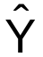 = 6.3972 + 20.4921X₁ + 0.002805X₂

where = Estimated # of ad. responses
X₁ = Ad. size (in.²)
X₂ = Newspaper circulation

Interpretation of b₁ and b₂:

b₁: The # of advertisement responses is expected to increase by 20.49 for each 1 in.² increase in advertisement size holding circulation constant.

b₂: The # of advertisement responses is expected to increase by .0028 for each 1 person increase in circulation holding advertisement size constant.

A more meaningful way to view b₂ is to consider a 10,000 person increase in circulation holding advertisement size constant. In this case, the # of advertisement responses would increase by 10,000*0.002805 = 28.05.

Estimate the # of advertisement responses for a 5 in.² advertisement in a newspaper with a circulation of 50,000.

> add.data<-data.frame(size = 5, circulation = 50000)
> predict(object = mod.fit, newdata = add.data)
[1] 249.1037

= 6.3972 + 20.4921∗5 + 0.002805∗50,000
= 249.1037

On average, about 249 advertisement responses should be expected.

> MSE<-sum.fit$sigma^2

> data.frame(set1, Y.hat =
round(mod.fit$fitted.values,2), e =
round(mod.fit$residuals,2), e.star =
round(mod.fit$residuals/sqrt(MSE),2))

ad.responses size circulation Y.hat e e.star
1 100 1 20000 82.99 17.01 0.59
2 400 8 80000 394.73 5.27 0.18
3 100 3 10000 95.92 4.08 0.14
4 300 5 70000 305.20 -5.20 -0.18
5 200 6 40000 241.55 -41.55 -1.44
6 400 10 60000 379.61 20.39 0.71

- Create a scatter plot of the data and of the sample regression model’s plane.

This plot will open up in a window outside of R. You can rotate it through the left mouse button (click, hold, move). You can zoom in and out with the right mouse button. Below is the code and screen captures.

> library(Rcmdr)
> scatter3d(formula = ad.responses ~ size + circulation,
fit="linear", bg="white", grid=TRUE)
> identify3d(formula = ad.responses ~ size + circulation,
data = set1, labels=1:6)
#Can not get identify3d() to work with my computer :(

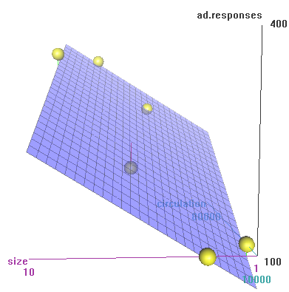

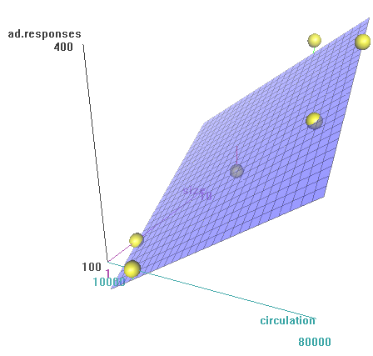

> #Additional options to change plot - allows one to see
the x, y, z-axis numbers
> library(rgl) #If Rcmdr is not actually open, will need
to use this (Rcmdr actually uses this
package for the 3D interactive plots)
> rgl.clear("all") #Clears plot window
> rgl.light() #Gray background
> rgl.bbox() #Puts numbers on plot and box around it
> scatter3d(formula = ad.responses ~ size + circulation,
data = set1, fit="linear", grid=TRUE, bg.col="black")
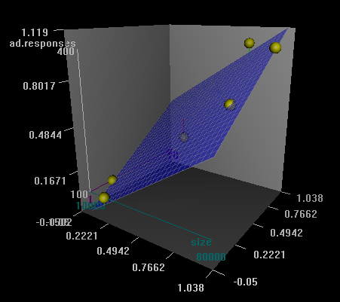

- Examine the relationship between ad. responses and a predictor variable holding the other predictor variable constant.

We can hold one predictor variable constant and look at a two dimensional graph. For example, suppose circulation = 45,000. Then the sample model becomes 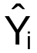 = 6.3972 + 20.49∗X_{i1} + 0.002805∗45,000 = 132.6186 + 20.49∗X_{i1}. Below is a plot of three different scenarios with circulation held constant. Notice how curve() used without a plot() function used first. Also, many of the same options used with plot() are used here with curve().

#Sample model holding circulation constant
win.graph(width = 6, height = 6, pointsize = 10)
curve(expr = mod.fit$coefficients[1] +
mod.fit$coefficients[2]*x +
mod.fit$coefficients[3]*10000, col = "red",
lty = "solid", lwd = 2, xlim = c(1,10), ylim = c(0,
500), xlab = "Size", ylab = "Estimated ad.
responses", main = "Estimated ad. responses vs. size
of ad. \n holding circulation constant", panel.first
= grid(col = "gray", lty = "dotted"))
curve(expr = mod.fit$coefficients[1] +
mod.fit$coefficients[2]*x +
mod.fit$coefficients[3]*45000, col = "blue",
lty = "solid", lwd = 2, add = TRUE, xlim c(1, 10))
curve(expr = mod.fit$coefficients[1] +
mod.fit$coefficients[2]*x +
mod.fit$coefficients[3]*80000, col =
"darkgreen", lty = "solid", lwd = 2, add = TRUE, xlim
= c(1, 10))
legend(locator(1), legend = c("Circulation = 10,000",
"Circulation = 45,000", "Circulation = 80,000"), col
= c("red", "blue", "darkgreen"), lty = c("solid",
"solid", "solid"), bty = "n", cex = 0.75)

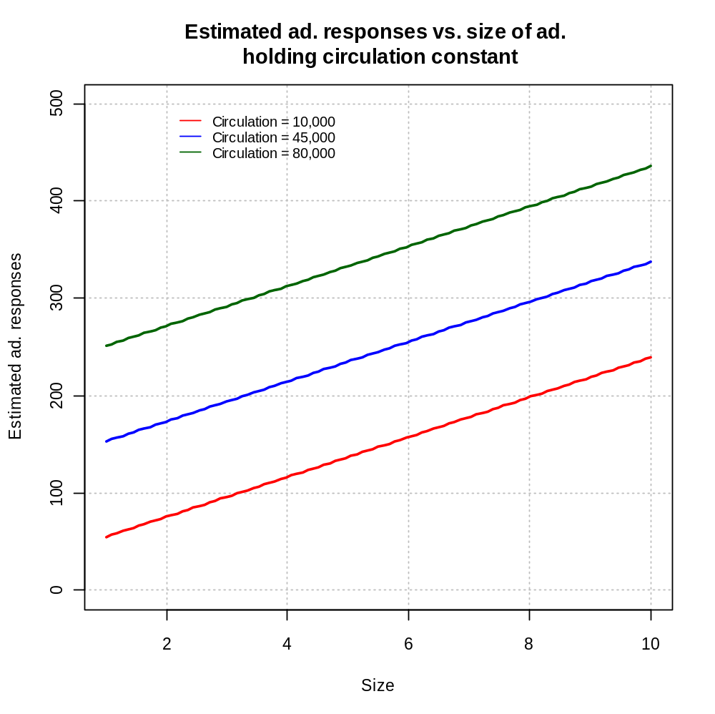
What type of an effect does size have on the estimated number of advertisement responses when circulation is held constant?

Plot for holding size constant:

#Sample model holding size constant
win.graph(width = 6, height = 6, pointsize = 10)
curve(expr = mod.fit$coefficients[1] +
mod.fit$coefficients[2]*1 +
mod.fit$coefficients[3]*x, col = "red",
lty = "solid", lwd = 2, xlim = c(10000, 80000),
ylim = c(0, 500), xlab = "Circulation", ylab =
"Estimated ad. responses", main = "Estimated ad.
responses vs. circulation \n holding size
constant", panel.first = grid(col = "gray", lty =
"dotted"))
curve(expr = mod.fit$coefficients[1] +
mod.fit$coefficients[2]*5.5 +
mod.fit$coefficients[3]*x, col = "blue",
lty = "solid", lwd = 2, add = TRUE, xlim = c(10000,
80000))
curve(expr = mod.fit$coefficients[1] +
mod.fit$coefficients[2]*10 +
mod.fit$coefficients[3]*x, col =
"darkgreen", lty = solid", add = TRUE, xlim =
c(10000, 80000))
legend(locator(1), legend = c("Size = 1", "Size = 5.5",
"Size = 10"), col = c("red", "blue", "darkgreen"),
lty = c("solid", "solid", "solid"), bty = "n", cex
= 0.75)
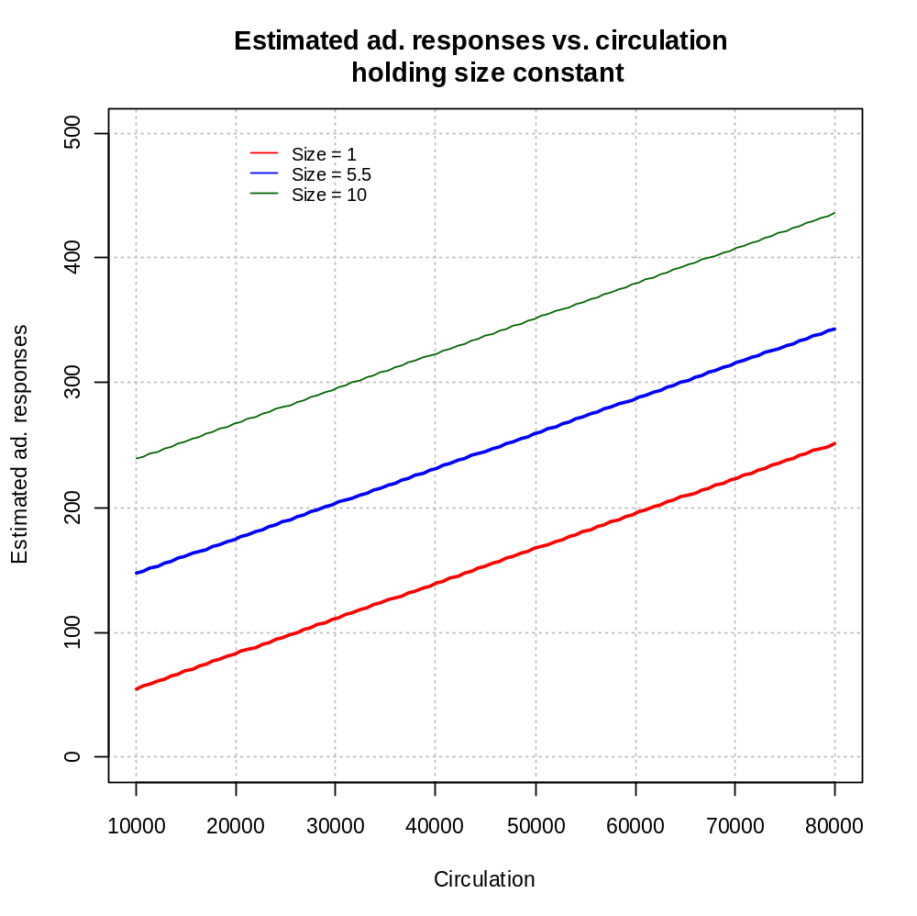
What type of an effect does circulation have on the estimated number of advertisement responses when size is held constant?
Example: NBA guard example (nba_example.R)

Evaluating the effectiveness of NBA guards in the 1992-3 season

One measure of effectiveness (performance) is the number of points scored per minute (PPM) of playing time. For example, Michael Jordan played 3,067 minutes and scored 2,543 points. Then PPM=2,543/3,067=0.8291.

Note:
Points scored per game (PPG) are usually used as a measure of performance instead of PPM. In Jordan’s example, he played 78 games and scored 2,543 points for a PPG=2543/78=32.6. PPM will be used in this course because not all of the “effective” guards get the same amount of playing minutes.

What factors could affect PPM?
- Minutes per game (MPG) – usually a team’s offense is centered on their regular players (the players with more minutes per game).
- Height – Taller players can shoot over smaller players.
- Age – Younger players are learning the game and/or players production decreases once they get past the prime of their career.
- FTP – Free throw percentage measures how successful a player is in scoring points at the free throw line.
- FGP – Field goal percentage measures how successful a player is in scoring points when they shoot the basketball (not at the free throw line).

Many other factors could also be examined.

A sample of NBA guards is taken from the 1992-3 season. Below is a partial listing of the data
Last Name | First Initial | PPM | MPG | Height(cm) | FTP | FGP | Age
Abdul-Rauf | M. | 0.5668 | 33.8750 | 185.0 | 93.5 | 45 | 24
Adams | M. | 0.4086 | 36.2174 | 178.0 | 85.6 | 43.9 | 30
Ainge | D. | 0.4419 | 26.7037 | 196.0 | 84.8 | 46.2 | 34
Anderson | K. | 0.4624 | 36.5455 | 185.0 | 77.6 | 43.5 | 23
Anthony | G. | 0.2719 | 24.2714 | 188.0 | 67.3 | 41.5 | 26
Armstrsong | B.J. | 0.3998 | 30.7654 | 188.0 | 86.1 | 49.9 | 26
Bagley | J. | 0.2371 | 9.7000 | 210.0 | 83.3 | 36 | 33
 |  |  |  |  |  |  | 

Suppose we want to predict PPM using the multiple linear regression model that includes MPG, Height, and FTP as the predictor variables.

> nba<-read.table(file =
"C:\\chris\\UNL\\STAT870\\Chapter6\\nba_data.txt",
header=TRUE, sep = "")
> head(nba)
last.name first.initial games PPM MPG height FTP FGP age
1 Abdul-Rauf M. 80 0.5668 33.8750 185 93.5 45.0 24
2 Adams M. 69 0.4086 36.2174 178 85.6 43.9 30
3 Ainge D. 81 0.4419 26.7037 196 84.8 46.2 34
4 Anderson K. 55 0.4624 36.5455 185 77.6 43.5 23
5 Anthony G. 70 0.2719 24.2714 188 67.3 41.5 26
6 Armstrsong B.J. 81 0.3998 30.7654 188 86.1 49.9 26

> mod.fit<-lm(formula = PPM ~ MPG + height + FTP, data =
nba)
> sum.fit<-summary(mod.fit)
> sum.fit

Call:
lm(formula = PPM ~ MPG + height + FTP, data = nba)

Residuals:
Min 1Q Median 3Q Max
-0.21345 -0.06595 -0.01632 0.05298 0.40052

Coefficients:
Estimate Std. Error t value Pr(>|t|)
(Intercept) -0.4021933 0.3010148 -1.336 0.184511
MPG 0.0040331 0.0011530 3.498 0.000699 ***
height 0.0035858 0.0014812 2.421 0.017271 *
FTP 0.0005883 0.0012409 0.474 0.636431
---
Signif. codes: 0 '***' 0.001 '**' 0.01 '*' 0.05 '.' 0.1 ' ' 1

Residual standard error: 0.1067 on 101 degrees of freedom
Multiple R-Squared: 0.1775, Adjusted R-squared: 0.153
F-statistic: 7.264 on 3 and 101 DF, p-value: 0.0001842

> jordan.stockton<-nba[nba$last.name == "Jordan" |
nba$last.name == "Stockton",]
> jordan.stockton
last.name first.initial games PPM MPG height FTP FGP age
52 Jordan M. 78 0.8291 39.3205 198 83.7 49.5 30
92 Stockton J. 82 0.4325 34.9146 185 79.8 48.6 31

> save.pred<-predict(object = mod.fit, newdata =
jordan.stockton)
> #Summary - notice how elementwise multiplication is used
for two vectors
> data.frame(Name = jordan.stockton$last.name,
PPM = jordan.stockton$PPM,
PPG = jordan.stockton$PPM*jordan.stockton$MPG,
PPM.hat =save.pred,
PPG.hat = save.pred*jordan.stockton$MPG)
Name PPM PPG PPM.hat PPG.hat
52 Jordan 0.8291 32.60063 0.5156282 20.27476
92 Stockton 0.4325 15.10056 0.4489484 15.67485

> #Look what happens with rounding error
> cbind(1, jordan.stockton$MPG, jordan.stockton$height,
jordan.stockton$FTP)%*%round(mod.fit$coefficients,4)
[,1]
[1,] 0.5181020
[2,] 0.4513384

Sample regression model:

= -0.4022 + 0.004033∗X₁ + 0.003586∗X₂ +
0.0005883∗X₃

where X₁=MPG, X₂=Height, and X₃=FTP

This can also be written as:

 = -0.4022 + 0.004033∗MPG + 0.003586∗Height +
0.0005883∗FTP

Interpretation of b₁, b₂, and b₃:

b₁: PPM is expected to increase by 0.004033 for each additional MPG (holding the other variables constant).

b₂: PPM is expected to increase by 0.003586 for each additional cm in height (holding the other variables constant).

b₃: PPM is expected to increase by 0.0005883 for each additional free throw percentage point (holding the other variables constant).

Estimate the PPG of a guard who plays 39.3205 minutes per game (on average), is 198cm (6 foot 6 inches) tall, and has an 83.7% free throw percentage.

=-0.4022 + 0.004033∗39.3205 + 0.003586∗198 + 0.0005883∗83.7
= 0.5156

These are Michael Jordan’s predictor variable values in the data set. Jordan had actually had a PPM=0.8291.

Translating this to points per game (PPG):
 = ∗ # of minutes play per game = 0.5156∗39.3205 = 20.3

PPG = 0.8291∗39.3205 = 32.6

The model does a poor job for Jordan.

Estimate the PPG of a guard who plays 34.9146 minutes per game (on average), is 185cm (6 foot 1 inch) tall, and has a 79.8% free throw percentage.

=-0.4022 + 0.004033∗34.9146 + 0.003586∗185 + 0.0005883∗79.8
= 0.4489

These are John Stockton’s independent variable values in the data set. Stockton actually had a PPM=0.4325

Translating this to points per game (PPG):
= 0.4489∗34.9146 = 15.7

PPG = 0.4325∗34.9146 = 15.1

The model does a better job for Stockton.

